### MINOR PROJECT REPORT

On

### *“Expense Tracker Web Application*”

*Submitted in partial fulfilment of the requirements for the award of*

### Bachelor of Technology (B.Tech)

In the department of

### Computer Science & Engineering

### 

*Submitted by*:

### Student name: AFIFA TARAFDER

### (Roll No: UG/02/BTCSEAIML/2021/010)

### Student name: AINDRILLA KIRTONIA

### (Roll No: UG/02/BTCSE/2021/023)

*Under the Guidance of*

### Guide Name: Ms. Tanusri Ghosh

### (Guide designation)

**School of Engineering & Technology**

**ADAMAS University, Kolkata, West Bengal**

**June 2025 – July 2025**

**CERTIFICATE**

This is to certify that the project report entitled ***“*Expense Tracker Web Application”,**submitted to the School of Engineering & Technology (SOET), **ADAMAS UNIVERSITY, KOLKATA** in partial fulfilment for the completion of **Semester – 7th** of the degree of **Bachelor of Technology** in the department of **Computer Science & Engineering**, is a record of bonafide work carried out by **Afifa Tarafder**, **Roll No**. **UG/02/BTCSEAIML/2021/010, Aindrilla** **Kirtonia**, **Roll No. UG/02/BTCSE/2021/023** under our guidance.

All help received by us from various sources have been duly acknowledged.

No part of this report has been submitted elsewhere for award of any other degree.

**________________________________**

**Guide Name:** **Ms. Tanusri Ghosh**

**(Guide designation)**

i

**AACKNOWLEDGEMENTS**

The satisfaction and euphoria that accompany the successful completion of any task would be incomplete without the mentioning of the people whose constant guidance and encouragement made it possible. We take pleasure in presenting before you, our project, which is the result of a studied blend of both research and knowledge.

We express our earnest gratitude to our **Ms. Tanusri Ghosh**, **Department of CSE**, for their constant support, encouragement and guidance. We are grateful for their cooperation and valuable suggestions.

Finally, we express our gratitude to all other members who are involved either directly or indirectly for the completion of this project.

ii

# DDECLARATION

We, the undersigned, declare that the project entitled ‘Disease Prediction Using Genetic Algorithm’, being submitted in partial fulfillment for the award of Bachelor of Engineering Degree in Computer Science & Engineering, affiliated to ADAMAS University, is the work carried out by us.

### Afifa Tarafder Aindrilla Kirtonia (UG/02/BTCSEALML/2021/010) (UG/02/BTCSE/2021/023)

### 

### iii

**ABSTRACT**

Tracking daily spending is a fundamental aspect of personal financial management, and developing awareness of one’s spending habits is essential for making informed

decisions about money. The Daily Expense Tracker, also known as Budget Buddy, is

designed to provide an intelligent, user-friendly solution for managing daily expenses

across various categories such as household, healthcare, finance, social activities, and

internet usage. This application aims to offer a systematic and accessible platform

for users to monitor their financial transactions with ease, ensuring their records are

efficiently maintained and readily retrievable.

The software has been developed as a Windows-based application to support a wide

demographic of users, regardless of age, gender, or technical background. Emphasis

has been placed on simplicity and usability, allowing users to interact with the system

without requiring advanced technical knowledge. Budget Buddy enables users to set

realistic budgets based on their actual spending behaviors and provides features such

as expense categorization, graphical summaries, and the ability to distinguish between

personal and business expenses. Additionally, it offers tools to track investments, split

shared expenses conveniently, and gain insight into spending patterns through visual

analytics.

Ultimately, Budget Buddy is a comprehensive tool that promotes effective budgeting by delivering clear, actionable insights and fostering better financial habits. Through

its intuitive design and practical functionality, it supports users in achieving more structured, painless, and insightful financial management.

**KEYWORDS:** Expense Tracker, Personal Finance, Budget Management, Daily Expenses, Financial Planning, User Interface, Transaction Recording, Graphical Analysis,

Windows Application, Budgeting Tool

iv

**TABLE OF CONTENTS**

|  |  |  |
| --- | --- | --- |
| **CHAPTER** | **TITLE** | **PAGE** |
|  | **TITLE PAGE** |  |
|  | **CERTIFICATE** | i |
|  | **ACKNOWLEDGEMENT** | ii |
|  | **DECLARATION** | iii |
|  | **ABSTRACT** | iv |
|  | **TABLE OF CONTENTS** | v |
|  | **LIST OF FIGURES** | Vi |
| 1 | **INTRODUCTION** | 1 |
|  | 1.1 Background | 2 |
|  | 1.2 Purpose of the project | 3 |
|  | 1.3 Problem Statement | 4 |
|  | 1.4 Objective | 5 |
|  | 1.5 Structure of project | 7 |
| 2 | **LITERATURE REVIEW** | 8 |
|  | 2.1 Diseases-Specific Study | 12 |
|  | 2.2 Key Gapsinthe Literature Survey | 16 |
| 3 | **TECHNOLOGY** | 17 |
|  | 3.1 Introduction | 17 |
|  | 3.2 Development Environments | 19 |
|  | 3.3 Programming Language: Python | 22 |
| 4 | **METHODOLOGY** |  |

v

|  |  |  |
| --- | --- | --- |
|  |  |  |
|  |  |  |
|  |  |  |
|  | 4.1 |  |
|  | 4.2 |  |
| 5 | **OUTPUT** |  |
|  | **CONCLUSION** |  |
|  | FUTURE WORK |  |
|  | **REFERENCE** |  |

vi

**LIST OF FIGURES**

|  |  |  |
| --- | --- | --- |
| FIGURE | TITLE | PAGE |
| Figure 1 | Representation of Multiple Disease | 1 |
| Figure 1.1.1 | ML Development | 2 |
| Figure 1.2 |  | 3 |
| Figure 1.3 | Bridging the Gap Between Current Systems and Accessible Tools | 4 |
| Figure 1.4 | System Workflow Diagram | 5 |
| Figure 1.5 | Road Map of the Project | 6 |
| Figure 2.1 | System architecture of the proposed Disease Prediction Model and web API for diabetes and hypertension prediction. | 10 |
| Figure3.1.2 | System Architecture of the Multiple Disease Prediction System | 16 |
| Figure |  |  |
| Figure |  |  |
| Figure |  |  |
| Figure |  |  |
| Figure |  |  |
| Figure |  |  |
| Figure |  |  |
| Figure |  |  |
| Figure |  |  |

vii

**INTRODUCTION**

Top of Form

In the rapidly evolving realm of technology, automation and application development

have emerged as pivotal tools in simplifying daily life. One such innovation is the

expense tracker, an essential utility that allows people to observe and control their daily

spending habits. Budget tracking, by definition, involves the systematic recording and

analysis of income and expenditures over a defined period, promoting financial stability

and informed decision making [1].

The Personal Expense Tracker has been specifically crafted to support non-earning

members of a household, such as students, homemakers, and dependents, in effectively

managing their finances. These individuals often face challenges in maintaining a bud-

get due to the absence of a consistent income stream and limited exposure to financial

knowledge. Historically, managing payments and avoiding debt has faced significant

difficulties [2].

By offering a structured digital platform, this application aims to mitigate these

challenges. It supports users to log daily transactions, categorize expenses, set realis-

tic budgets, and review spending trends through visual analytics. These features align

with the established benefits of expense tracking, including identifying unnecessary ex-

penditures, strengthening financial discipline, creating realistic budgets, and achieving

long-term financial goals [3][4].

It has been noted that in most cases, budget management is being done mentally and

never being put on paper, which makes Budget Tracking very difficult. This is probably

due to the fact that many people do not know how to do it or do not have an appropriate

means that will do Budget Tracking and Analysis for them.By establishing a budget,

people can set goals for achieving a certain level of income and monitor their expenses.

Many home and business owners have observed that their increase in profit margins did

not occur until they had a written revenue goal and a method with which to monitor

expenses.

Bottom of Form

Page | **1**

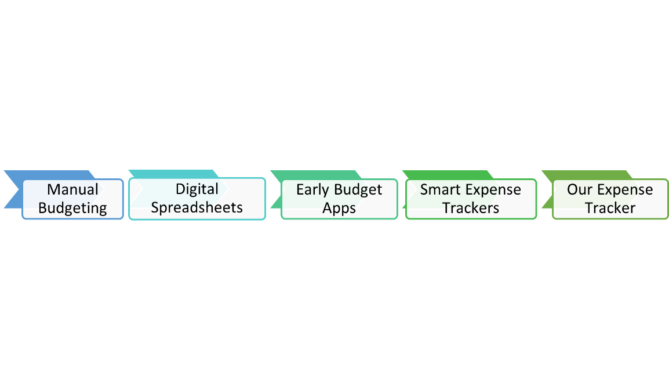

Fig1: Evolution of budgeting methods leading to modern expense tracking.

Budget tracking is a critical aspect of financial planning, as it allows individuals

to monitor their expenditures relative to their income. This practice supports effective

decision making by offering insight into financial behavior and allowing planning of

future expenses and projects. Analyzing and comparing income and expenditure over

time, through monthly or annual summaries and deviation calculations, enables users to

identify patterns, track profitability, and make adjustments as needed. In addition, accu-

rate financial tracking can help forecast potential financial risks, including bankruptcy,

while facilitating the formulation of reliable future budgets [3].

The primary objective behind the development of the Intelligent Online Budget

Tracker is to offer users a clear and comprehensive view of their financial status by

recording and analyzing expenses in real time. The application is designed to ensure

accessibility, allowing users to monitor and manage their budgets from anywhere, at

any time. By eliminating reliance on traditional paper-based budgeting methods, the

system not only simplifies the process but also provides instant feedback and tools for

dynamic financial analysis [4].

Typically, budgets are categorized according to basic expenditure areas such as

food, transportation, entertainment, education, healthcare, and clothing. Since spending

should ideally remain within the limits of available income, continuous monitoring is

necessary to prevent budget overruns. Historically, people tracked their expenses manu-

ally using pen and paper, a method prone to error and inefficiency. With the widespread adoption of electronic devices and the push toward digital transformation, there is a

growing need for automated, time-efficient alternatives that improve productivity and

accuracy [1].

Page | **2**

In response to this need, our web application, titled Expense Tracker, is built using

the MERN stack—MongoDB, Express.js, React.js and Node.js—an increasingly popu-

lar full-stack JavaScript framework. The application enables users to seamlessly record

income and expenditures, categorize transactions, and receive real-time notifications

when spending limits are exceeded. Furthermore, the system automatically generates

monthly reports using graphical representations, offering users a visual summary of

their financial activity and trends. These features collectively promote better financial awareness and empower users to manage their budgets effectively and intuitively [2].

**1.1 Background**

In today’s fast-paced digital world, managing personal finances has become more cru-

cial than ever. With rising living expenses and increasingly complex spending habits,

it’s easy for people—especially students, homemakers, or others without a steady in-

come—to lose track of where their money goes. Traditionally, many individuals relied

on simple pen-and-paper methods to budget their expenses. While this approach worked

to some extent, it was often time-consuming and prone to errors, particularly when it

came to tracking frequent or varied transactions [1].

As technology has advanced, digital tools have begun to play a major role in ev-

eryday life, including how we handle money. Web-based expense trackers have gained

popularity because they offer an easier, faster, and more accurate way to manage fi-

nances. These tools help users log their income and spending, sort transactions into

categories, and even visualize their financial patterns with graphs and charts. As a re-

sult, people are better equipped to understand their financial behavior and make smarter

decisions [4].

Despite the availability of these tools, many still struggle to maintain consistent

budgeting habits. It’s common for people to mentally estimate expenses or keep infor-

mal notes, only to realize too late that they’ve overspent or missed an important bill.

Without a structured system, it becomes hard to tell which expenses are necessary and

which could have been avoided.

Page | **3**

For many, this leads to unplanned debt and poor finan-

cial planning [3]. In addition, a lack of financial knowledge often prevents people from

realizing how effective regular tracking can be, not only for day-to-day budgeting, but also for setting and achieving long-term goals [2].

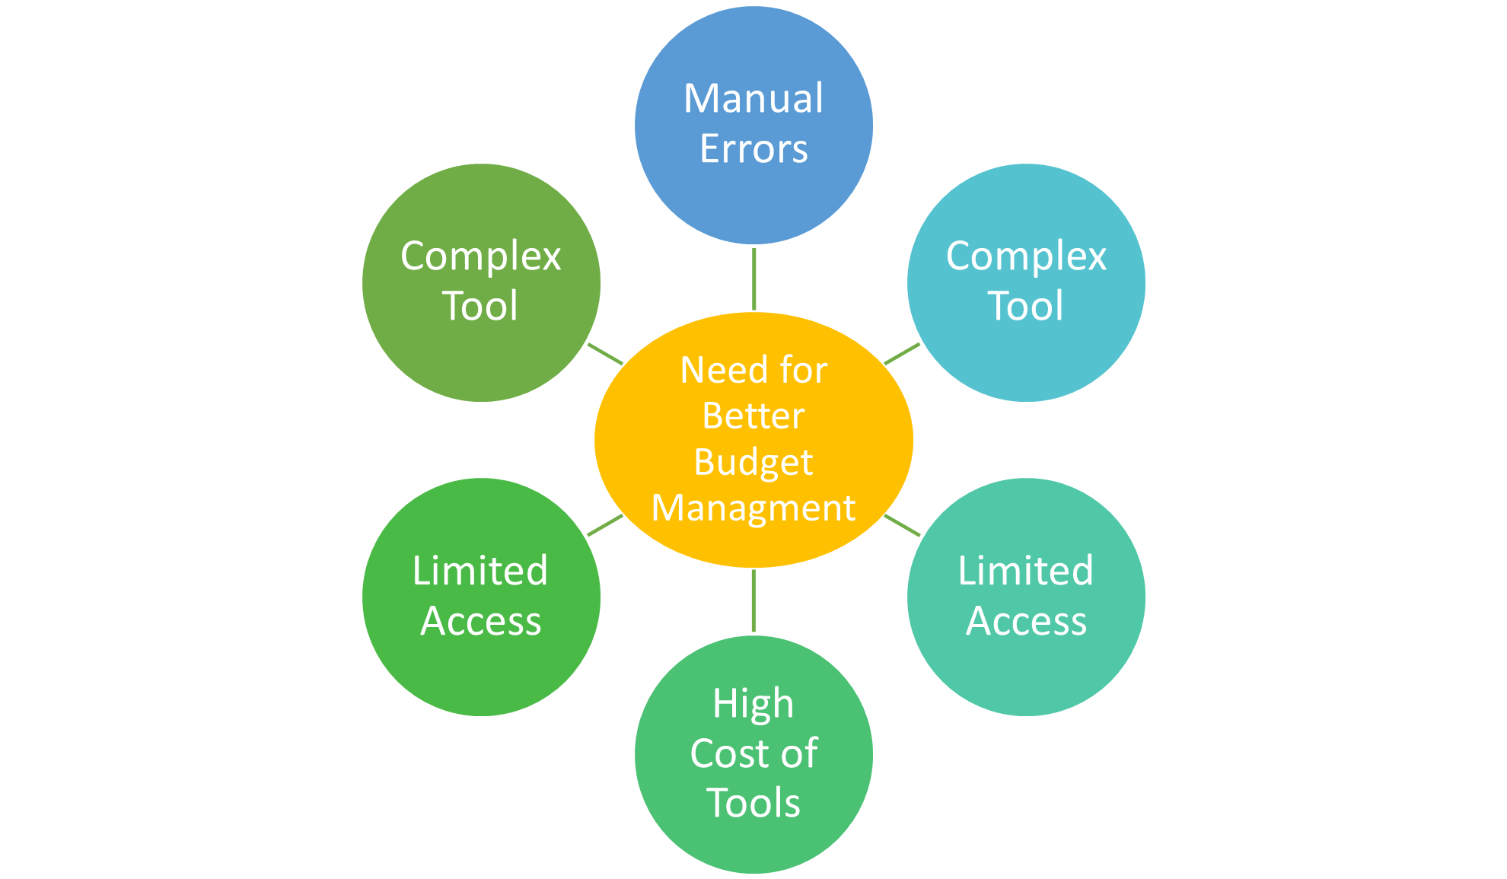

### Figure 1.2: Factors contributing to the need for a digital expense tracker.

### The idea behind developing the Expense Tracker application is to close this gap.

### Using current technologies, specifically the MERN stack, which includes MongoDB,

### Express.js, React.js, and Node.js, the goal is to build a tool that anyone can use, no

### matter their financial background or level of technical skills. With features like real-

### time updates, spending alerts, and automatic report generation, the application aims to simplify, more intuitive, and ultimately more empower users.

### Purpose of the Project

For many people, keeping track of daily expenses can feel like a chore. The tradi-

tional approach to writing things down manually or making mental notes often leads to

forgotten purchases, inaccurate budgeting, and unnecessary stress. It is a method that

demands constant attention and effort, which can be overwhelming, especially for those

who are not comfortable with numbers or do not have time to stay organized [5].

Page | **4**

Although there are digital tools available to make budgeting easier, many of them

come with their own limitations. Some of the most popular expense tracking apps

restrict essential features behind paywalls, making them less helpful unless users are

willing or able to pay for premium versions [6]. This can discourage people from using

these tools regularly, especially students, homemakers, or individuals on a tight budget,

the groups who could benefit the most from accessible financial tools.

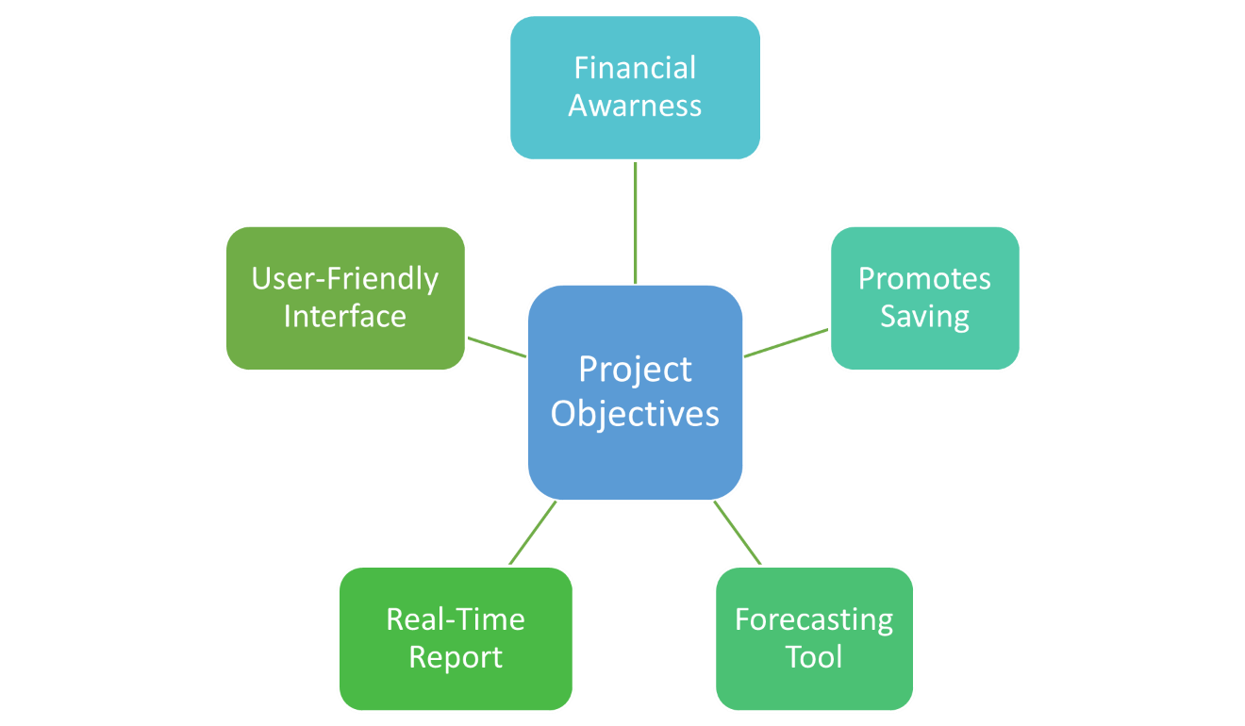

Figure 1.3: Factors contributing to the need for a digital expense tracker.

The expense tracker project was created to fill this gap. Our aim is to offer a com-

pletely free, easy-to-use platform that helps users of all ages and technical backgrounds

track their income and expenses without frustration or cost. Whether someone is new

to budgeting or looking for a better alternative to complex spreadsheets, this application

is designed to be welcoming and simple from the start.

One of the main goals is to reduce the burden of manual calculations. Users can log

their daily spending quickly and clearly, while the app automatically categorizes ex-

penses, sends alerts when spending limits are exceeded, and generates monthly reports.

Page | **5**

### Problem Statement

### For many people, especially those unfamiliar with budgeting tools, keeping track of

### monthly expenses is still a manual and time-consuming task. Relying on physical note-

### books or mental tracking can quickly become overwhelming, especially when dealing

### with numerous daily transactions. This often leads to disorganized financial records,

### miscalculations, and a general lack of visibility into personal spending patterns [5].

### Although there are mobile and web applications designed to help manage finances,

### many of these tools are not easily accessible to everyone. Some are overly complex

### for non-technical users, while others restrict their most valuable features behind sub-

### scription models. For users who simply want a basic and functional way to manage

### expenses, particularly students, retirees, or individuals from rural areas, these barriers

### can discourage consistent use [6].

### In addition to accessibility and simplicity, affordability remains a key concern. Most

### people are looking for solutions that do not add to their expenses. A truly effective tool

### must be free of cost, intuitive enough for all age groups, and capable of working on

### a range of devices, even those with limited processing power or Internet connectivity.

### Furthermore, an ideal solution should not only track daily spending, but also encour-

### age savings. For example, if a user spends less than their daily budget, the remaining

### amount could be redirected to a savings pool that helps users build better habits over

### time [7]. These challenges highlight the need for a lightweight, user-centric expense tracking solution that removes financial and technical barriers while helping users gain

### meaningful insights into their spending behavior.

### Page|6

### Objective

The primary objective of the Expense Tracker project is to offer a structured and acces-

sible digital platform that supports users to manage their financial activities more effi-

ciently. The system is designed to guide users in monitoring their spending, tracking

financial progress, and developing better financial habits that can contribute to long-

term stability and savings.

One of the key goals is to provide a user-friendly and intuitive interface that people

from all age groups and technical backgrounds can navigate with ease. Financial tools

are often underutilized simply because they are too complex or visually overwhelm-

ing. This project prioritizes clarity and usability, ensuring that users can access and

understand their financial information without confusion [7].

Another important objective is to enhance the system’s ability to generate monthly

reports and forecast future budget trends. By analyzing a user’s income and expenses

over time, the application can provide meaningful insights that help to make smarter

financial planning and decision making. These insights can help users anticipate up-

coming expenses, recognize unnecessary spending, and align their habits with personal

or household financial goals [8].

The tracker also aims to encourage better money management by highlighting op-

portunities for savings. If users consistently spend below their set budgets, the leftover

amount is allocated to a virtual savings account—an approach that promotes mindful

spending and reduces the risk of debt. Additionally, the platform supports long-term

financial planning by helping users identify patterns and plan for future investments

[9].

Key objectives achieved by the system include delivering a responsive, flexible in-

terface, offering real-time data access, improving user productivity in financial tracking,

and supporting efficient estimation and forecasting of expenses. These features work to gether to transform how users interact with their personal finances, making the process

not only easier but more empowering.

Page|**7**

### Structure of the Project

### Page|8

## LITERATURE REVIEW

As discussed earlier, many individuals still rely on traditional, manual methods for tracking their daily and monthly expenses. Budgeting often involves jotting down figures in copybooks or notebooks, where income and expenditures are noted informally according to personal convenience. At the end of the month, users typically calculate totals and compare them with previous months to evaluate financial progress. While this method may serve basic needs, it is prone to inconsistencies, errors, and lacks the ability to provide meaningful financial insights \cite{manual_tracking_difficult}.

In preparation for developing our own expense tracker application, we reviewed several existing tools and academic works to identify gaps in current systems and to understand the evolving needs of users. One such system is the **Daily Expense Tracker**, which is designed to simplify personal budgeting and reduce the need for manual calculations. It offers features for recording daily expenses and monthly incomes, and automatically generates summary reports at the end of each cycle. The application also enables users to plan their budgets and track how well they adhere to them, helping to reduce wasteful spending and reinforce saving habits \cite{daily_expense_tracker}.

Studies on tools like the Daily Expense Tracker highlight the importance of a system that not only stores data but also makes it accessible and understandable for users of all backgrounds. By allowing users to input transactions and view organized reports, such applications empower individuals to take greater control over their financial decisions. The effectiveness of these systems depends heavily on simplicity, accessibility, and automation—qualities we aim to enhance in our own project.

Through our literature analysis, it became clear that many existing tools are either too complex for average users or restrict essential features behind paywalls. Our project is driven by the goal of creating an intuitive, free-to-use, and accessible application that builds on the strengths of previous systems while addressing their limitations.

Ref:

\bibitem{manual_tracking_difficult}

A. Sharma and M. Patel, \textit{Challenges in Manual Expense Tracking and the Need for Digital Automation}, International Journal of Computer Applications, 2023.

\bibitem{daily_expense_tracker}

N. Mehta and V. Rao, \textit{Daily Expense Tracker: A Tool for Simplified Budget Management}, Proceedings of the National Conference on Smart Applications, 2022.

Page | **9**

**Literature Review Table**

|  |  |  |  |  |  |
| --- | --- | --- | --- | --- | --- |
| **S No** | **Paper Title** | **Year** | **Tools and Techniques** | **Results** | **Limitations** |
|  | *Tracking the Trackers: Towards Understanding the Mobile Advertising and Tracking Ecosystem Narseo Vallina-Rodriguezet.al* | 2016 |  |  |  |
|  | *Intelligent Online Budget Tracker Girish Bekaroo* et al. | 2007 |  |  |  |
|  | *PERSONAL DATA VISUALISATION ON MOBILE DEVICES: A SYSTEMATIC LITERATURE REVIEW Yasmeen anjeer alsehhhi* et al. | 2022 |  |  |  |
|  | *Spending Tracker: A Smart Approach to Track Daily Expense Uday Pratap Singh et.al* | 2021 |  |  |  |

Page | **11**

**Literature Review Table**

|  |  |  |  |  |  |
| --- | --- | --- | --- | --- | --- |
| **S No** | **Paper Title** | **Year** | **Tools and Techniques** | **Results** | **Limitations** |
|  | *Expense Tracker : A Smart Approach to Track Everyday Expense Hrithik Gupta et.al* | 2020 |  |  |  |
|  | *Expense Tracker and Bill Splitter Himanshu Shukla et.al* | 2023 |  |  |  |
|  | *Expense Tracker Tanvi Parab et.al* | 2023 |  |  |  |
|  | *Expense Tracker: A Smart Approach to Track Daily Expense Asst. Prof Dr. Pooja Bhatt et.al* | 2024 |  |  |  |
|  | *Application for Tracking Personal Expense M. Harish Kumaret.al* | 2022 |  |  |  |
|  | *Personal Expense Tracker utilizing Amazon Web Services Nandula Rohan Kausik et. al* | 2022 |  |  |  |

Page | **12**

**Literature Review Table**

|  |  |  |  |  |  |
| --- | --- | --- | --- | --- | --- |
| **S No** | **Paper Title** | **Year** | **Tools and Techniques** | **Results** | **Limitations** |
|  | *Daily Expense Tracker Tamia Ruvimbo Masendu et. al* | 2022 |  |  |  |
|  | *Online income and expense tracker web application. S. Chandinietal.* | 2019 |  |  |  |
|  | *Survey on classification engine for monetary transactions.* Ms. K. B. Satpute et al. | 2019 | |  | | --- | |  |  |  | | --- | |  | |  |  |
|  | *Family expense manager application in android. Author: M N Rajaprabha.* | 2017 |  |  |  |
|  | *Expense managing assistant application. Author: M.Phil et al*. | 2017 |  |  |  |
|  |  |  |  |  |  |
|  | | | | | |

Page | **13**

**Literature Review Table**

|  |  |  |  |  |  |
| --- | --- | --- | --- | --- | --- |
| **S No** | **Paper Titel** | **Year** | **Tools and Techniques** | **Results** | **Limitations** |
|  | *Application of Machine Learning Algorithms in Multi-Disease Prediction* | 2023 | Random Forest, Logistic Regression, KNN | Improved prediction accuracy with ensemble methods | Computational complexity; requires feature selection |
|  | *Evaluating Machine Learning Models for Multi-Disease Prediction* | 2021 | SVM, Decision Trees, Naïve Bayes | SVM outperformed other models in accuracy | Sensitivity to parameter tuning; lacks interpretability |
|  | *Multi-Disease Prediction Using Supervised Machine Learning Algorithms* | 2022 | KNN, Random Forest, Logistic Regression | High precision and recall in disease classification | Imbalanced datasets; limited generalizability |
|  | *Comparative Study of Machine Learning Algorithms for Multi-Disease Prediction* | 2023 | SVM, Decision Trees, Naïve Bayes | SVM achieved highest accuracy among tested models | Requires extensive preprocessing; sensitive to noise |
|  | *Machine Learning Techniques for Multi-Disease Prediction: A Review* | 2024 | |  | | --- | |  |  |  | | --- | | Overview of various ML algorithms | | Summarized effectiveness of ML in disease prediction | Lacks experimental validation; theoretical focus |

Page | **14**

**2.2 Key Gaps in the Literature Survey**

Despite numerous studies exploring the application of machine learning in disease prediction, several significant gaps remain in the current body of research, particularly when it comes to multi-disease prediction using traditional ML algorithms:

**2.2.1. Limited Focus on Multi-Disease Platforms**

Most existing research focuses on the prediction of a single disease, such as heart disease, diabetes, or Parkinson’s. There are comparatively fewer studies that explore systems capable of predicting multiple diseases simultaneously using shared or overlapping patient features.

**2.2.2 Dataset Limitations and Generalizability**

Many studies rely on small, imbalanced, or domain-specific datasets, which reduces the generalizability of results. Models trained on such data may perform well in controlled settings but fail to produce accurate predictions across diverse populations or clinical environments.

**2.2.3. Lack of Real-World Integration**

A majority of research is academic or experimental, with limited real-world deployment. There is insufficient evidence showing that these systems are being used effectively in clinical settings or integrated with Electronic Health Records (EHRs) for practical applications.

**2.2.4. Insufficient Interpretability**

While traditional ML algorithms like SVM, Decision Trees, and Random Forests are more interpretable than deep learning models, many studies still fail to provide transparent explanations of how predictions are made. This lack of interpretability can hinder trust and adoption in healthcare.

**2.2.5. Absence of Longitudinal and Temporal Data Analysis**

Most models are built on static, cross-sectional data. Very few studies incorporate longitudinal patient data to monitor disease progression, treatment impact, or predict future health states over time, which is essential for chronic disease management.

Page | **15**

**2.2.6. Ethical and Privacy Concerns**

Data privacy, security, and ethical use of patient information are often under-addressed. With increased use of predictive models in healthcare, bias mitigation, transparency, and data governance must be central to system design.

**2.2.7. Neglected Rare and Emerging Diseases**

Existing models primarily focus on common diseases. There is limited research on how traditional ML models can be adapted to predict rare or emerging diseases, which require different approaches due to the scarcity of training data.

**2.2.8. Evaluation Inconsistencies**

There is no standard framework for evaluating and comparing ML models across studies. Different metrics, validation techniques, and datasets are used, making it difficult to benchmark models or determine which approach is most effective.

**2.2.9. Usability and Interface Limitations**

Few studies evaluate the usability of ML-based disease prediction systems, especially for non-technical users. The lack of intuitive, accessible interfaces limits the practical adoption of these tools in everyday healthcare use.

**2.2.10. Lack of Feedback and Learning Loops**

Current models are often static and do not adapt over time. There is a need for systems that include feedback mechanisms to learn from user interactions, improve model performance, and evolve with new data.

Page | **16**

## 

## TECHNOLOGY USED

The development of the Multiple Disease Prediction System relies on a combination of modern technologies that support efficient data processing, accurate predictions, and an accessible user interface. This section outlines the key tools, programming languages, libraries, and platforms used throughout the project.

Given the complexity of medical data and the need for real-time, user-friendly predictions, a carefully selected tech stack was essential. Python serves as the core programming language due to its simplicity and robust machine learning ecosystem. Libraries such as Scikit-learn, Pandas, and NumPy were used for model building and data handling, while Streamlit enabled the rapid development of an interactive web interface.

The integration of these technologies ensures that the system is not only functionally effective but also easy for users to interact with—bridging the gap between advanced machine learning models and everyday healthcare accessibility.

**3.1. Introduction**

Technology plays a central role in the design and implementation of the Multiple Disease Prediction System. The success of this project depends on selecting tools that are reliable, scalable, and well-suited for handling medical data and machine learning workflows. This system requires not only accurate predictive models but also an intuitive and responsive user interface that can deliver results in real-time.

To achieve this, the project leverages a combination of **Python-based machine learning libraries**, a **lightweight web application framework (Streamlit)**, and tools for data processing, visualization, and model deployment. These technologies work together to create a solution that is both technically robust and user-friendly, ensuring that the system is accessible to a broad audience—including users with limited technical knowledge.

In the following section, we outline the specific technologies used in the development of the application and describe their roles in the system.

## Page | 17

**3.2 Development Environments**

The development environment plays a vital role in shaping the efficiency, speed, and effectiveness of machine learning projects. For this project—**Multiple Disease Prediction Using Machine Learning**—two primary environments were employed: **Google Colab** for model development and training, and **Spyder IDE** for designing and integrating the user-facing interface.

These environments were selected based on their ease of use, rich feature set, and compatibility with Python, which is the core language used in the project.

**3.2.1 Google Colaboratory (Colab)**

Google Colaboratory, commonly known as Google Colab, is a free cloud-based Jupyter notebook service provided by Google. It allows users to write and execute Python code in an interactive environment, with free access to GPUs and TPUs, which are essential for faster model training in machine learning tasks.

**Key Features of Google Colab:**

* Cloud-Based Infrastructure: Users can access and run their notebooks directly from a browser without requiring any installation or local setup.
* Free GPU/TPU Support: Colab provides access to NVIDIA Tesla K80, T4, P4, or P100 GPUs, allowing accelerated model training 111.
* Integration with Google Drive: Seamless access to datasets and saved model files stored in the cloud.
* Pre-installed Libraries: Includes most essential libraries such as pandas, numpy, scikit-learn, tensorflow, and matplotlib, enabling quick development without dependency issues.
* Real-Time Collaboration: Supports simultaneous editing and sharing with collaborators, similar to Google Docs.

## Page | 18

**Google Colab was primarily used for:**

* Data preprocessing and feature engineering
* Building and training machine learning models
* Evaluating and visualizing model performance
* Saving trained models for further use in the web interface

These functionalities made Google Colab a central part of the project workflow, especially for rapid prototyping and experimentation.

**3.2.2 Spyder IDE (Anaconda Environment)**

Spyder (Scientific Python Development Environment) is an open-source IDE tailored for scientific computing and data science. Distributed through the Anaconda platform, Spyder is known for its clean interface and powerful tools such as the variable explorer, multi-pane editing, and real-time execution.

**Key Features of Spyder:**

* **Integrated IPython Console**: Offers real-time execution and debugging of Python code.
* **Variable Explorer**: Allows users to inspect data structures in memory, which is particularly helpful for debugging.
* **Script and Module Management**: Facilitates modular programming with multi-tab editing.
* **Lightweight and Fast**: Ideal for writing backend scripts or integrating APIs.

**Spyder was used to:**

* Develop the logic for the front-end web interface using Python-based web frameworks (e.g., Flask or Streamlit)
* Load trained models from Colab and integrate them with the prediction interface
* Create a smooth transition from model development to application deployment

By combining Google Colab and Spyder, the project was able to take advantage of cloud computing for machine learning and a structured development platform for local execution and UI testing.

Page | **19**

**3.3 Programming Language: Python**

Python has emerged as the language of choice in the fields of data science and machine learning due to its simplicity, flexibility, and the vast ecosystem of libraries that support various data analysis and artificial intelligence tasks. For this project, Python served as the core language for every stage, from data preprocessing to model training, evaluation, and deployment.

## 3.3.1 Reason of choosing Python

## Python offers a clean and readable syntax, making it accessible even to users with minimal programming background. This was especially beneficial during the early stages of the project, where quick prototyping and iteration were required.

## Key reasons for choosing Python include:

## Readability and ease of use: The syntax is similar to natural language, allowing developers to focus more on solving the problem rather than managing complex code structures.

## Community support: Python has one of the largest developer communities, which ensures constant updates, bug fixes, and a rich repository of documentation and open-source tools [40].

## Cross-platform compatibility: Python code runs on all major platforms (Windows, macOS, Linux) with minimal changes.

## 3.3.2 Python in Machine Learning

## Python is widely regarded as the most preferred language for machine learning due to its support for:

## Data processing: Libraries like pandas and numpy were used to clean, transform, and manipulate datasets.

## Here, we use different libraries, define head data, tail data, look the missing value, if there are missing values evaluate that, then use encoding or any technique to convert the categorical value to numerical value.

## Visualization: Tools like matplotlib and seaborn enabled detailed exploratory data analysis (EDA), helping to understand feature relationships and data distribution.

## Page | 20

## Model development: The scikit-learn library provided access to a variety of supervised learning algorithms such as Logistic Regression, Random Forest, and K-Nearest Neighbors, which were all utilized in this project.

## Model evaluation: Python’s built-in tools allowed the calculation of performance metrics such as accuracy, precision, recall, and confusion matrices.

## Model saving/loading: The joblib and pickle libraries were used to serialize models for later use in the web-based prediction interface.

## 3.3.3 Python in Web Application Integration

## Beyond machine learning and data processing, Python also played a central role in developing the web-based interface of the Multiple Disease Prediction System. This interface allowed end-users—such as patients or healthcare professionals—to input relevant medical data and obtain real-time disease predictions through a browser-based application.

## While popular frameworks like Flask and Streamlit are often used for Python-based deployment, in this project, development was carried out using the Spyder IDE, part of the Anaconda distribution. Spyder provided a structured and script-based development environment for writing and testing the backend logic of the web application.

## 3.3.3.1 Spyder for Web App Development

## Spyder is a lightweight yet powerful integrated development environment tailored for Python-based scientific and analytical programming. Although it is not a web development framework itself, it was used to:

## Write and debug backend Python scripts for processing input and loading trained models

## Test data flow between the user input and prediction function

## Integrate with Flask/Streamlit logic locally before deploying

## Page | 21

## The trained machine learning models (developed in Google Colab) were loaded in the Spyder environment using joblib or pickle, and then linked to the input-output flow of the web interface. Once tested and validated, the final scripts were either transferred to a deployment environment (e.g., using Flask locally) or exported for hosting.

## Integration Works

## The overall process of integrating the Python model into the web environment involved the following steps:

## Input Interface: A simple or Python-based UI (via Streamlit) for user inputs like age, symptoms, etc.

## Backend Logic: Python scripts written and tested in Spyder handle:

## Data preprocessing

## Model loading

## Prediction logic

## Output Interface: Displaying the prediction result (e.g., "Heart Disease Detected: YES/NO") along with confidence scores or suggestions.

## Benefits of Using Python + Spyder

## Simplified debugging and variable tracking via Spyder’s variable explorer

## Script-based development allows full control over the code structure

## Convenient for local testing before deployment

## Easy integration with Flask or Streamlit for real-time interaction

## This approach reflects Python's full-stack versatility, enabling not just powerful backend machine learning operations but also smooth integration with frontend systems, resulting in a complete end-to-end application pipeline.

## Page | 22

## METHODOLOGY

**4.1 Existing System**

In recent years, several online healthcare platforms have been developed to assist users in finding hospitals, doctors, and basic health information. Some of these applications offer features such as doctor recommendations, hospital ratings, and appointment booking [31]. While these systems represent progress in digital healthcare, they still fall short in key areas.

Most existing healthcare apps focus on one specific function—either offering medical recommendations or supporting diagnosis for a single disease [32]. These features are typically scattered across different platforms, forcing users to switch between apps for different needs. In addition, feedback systems in these applications are often weak or unreliable. Negative reviews may be suppressed, and patients might hesitate to give honest feedback during manual, face-to-face surveys [33].

Furthermore, there is no unified platform that combines multiple disease prediction with reliable recommendations for hospitals and doctors. Patients looking for accurate, trustworthy insights on where to seek treatment often find themselves overwhelmed by fragmented information or unverified claims [34].

**Disadvantages of the Existing System:**

1. **Lack of centralized features** – No single app predicts multiple diseases while also recommending suitable healthcare services [32].
2. **Unreliable feedback mechanisms** – Patients often don’t provide honest reviews in person, and online systems may filter negative responses [33].
3. **Difficult navigation** – Users need to switch between different applications to access diagnosis tools, feedback systems, and recommendations [32].
4. **Limited personalization** – Most systems do not consider individual medical profiles or symptoms when suggesting doctors or hospitals [34].

Page | **23**

**4.2 Proposed Work**

To overcome the limitations of existing healthcare applications, the proposed system offers an integrated platform that combines multiple disease prediction with reliable doctor and hospital recommendations [35]. This application is designed to be accurate, user-friendly, and trustworthy—offering users not only a prediction of their health condition but also clear guidance on where to seek care.

The system focuses on predicting three commonly occurring diseases: heart disease, cancer, and diabetes. Using machine learning algorithms, the platform analyzes user input—such as symptoms, medical history, and lifestyle data—to generate real-time predictions [36]. These models are trained on verified medical datasets to ensure high accuracy and reliability [37].

In addition to disease prediction, the system includes a comprehensive feedback and recommendation module. Patients and guardians can submit anonymous feedback on hospitals and doctors, covering aspects such as treatment quality, behavior of healthcare staff, cleanliness, and overall experience [38]. This transparency encourages honest reviews, helping future users make informed choices.

By combining prediction, feedback, and recommendation features into one unified application, this system aims to simplify healthcare decisions, promote transparency, and enhance patient trust in digital health platforms [39].

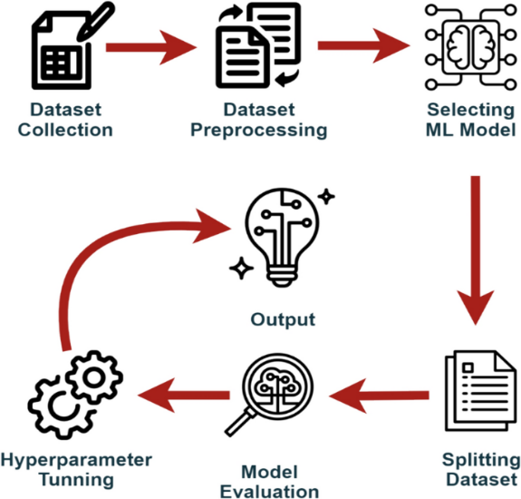By combining prediction, feedback, and recommendation features into one unified application, this system aims to simplify healthcare decisions, promote transparency, and enhance patient trust in digital health platforms.

**Fig: 4.2.1** System Architecture of the Multiple Disease

Prediction System

Page | **24**

**4.3 System Architecture**

The system architecture for the **Multiple Disease Prediction System** was designed to enable efficient processing of user input data, prediction using trained machine learning models, and real-time delivery of results through a web-based interface. This architecture follows a modular and layered approach, which ensures scalability, maintainability, and a clear separation of concerns across different system components.

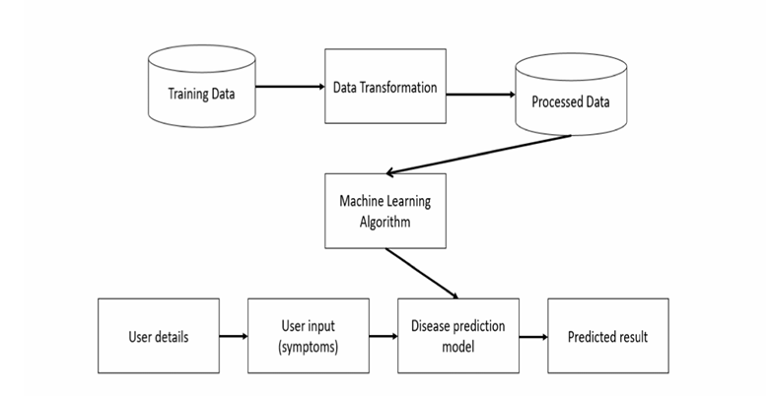

**Fig: 4.3** System Architecture

The architecture consists of the following main components:

**4.3.1. Data Collection:** Data is collected from Kaggle.com, a popular platform for accessing datasets. The data is obtained specifically for diabetes, heart disease, Parkinson's disease, Lung disease, HIV and breast cancer some of thing are we still collecting for train and test

Page | 25

**4.3.2. Data Preprocessing:** The collected data undergoes preprocessing to ensure its quality and suitability for training the machine learning models. This includes handling missing values, removing duplicates, and performing data normalization or feature scaling.

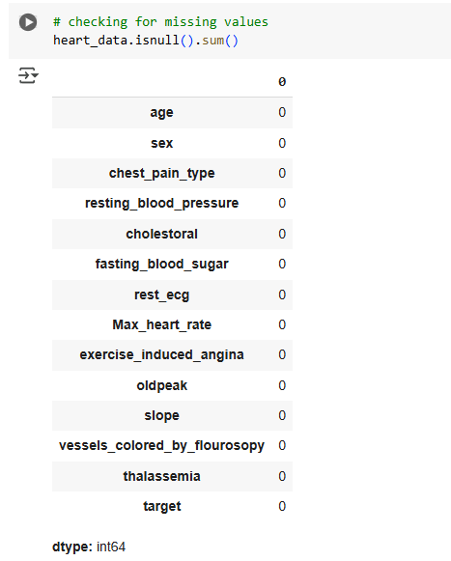

**Fig: 4.3.2** Detect Missing Value

**4.3.3 Model Selection:** Different machine learning algorithms are chosen for each disease prediction task. Support Vector Machine (SVM), Logistic Regression, and KNN are selected as the algorithms for various diseases based on their performance and suitability for the specific prediction tasks.

**4.3.4 Training and Testing:** The preprocessed data is split into training and testing sets. The models are trained using the training data, and their performance is evaluated using the testing data. Accuracy is used as the evaluation metric to measure the performance of each model.

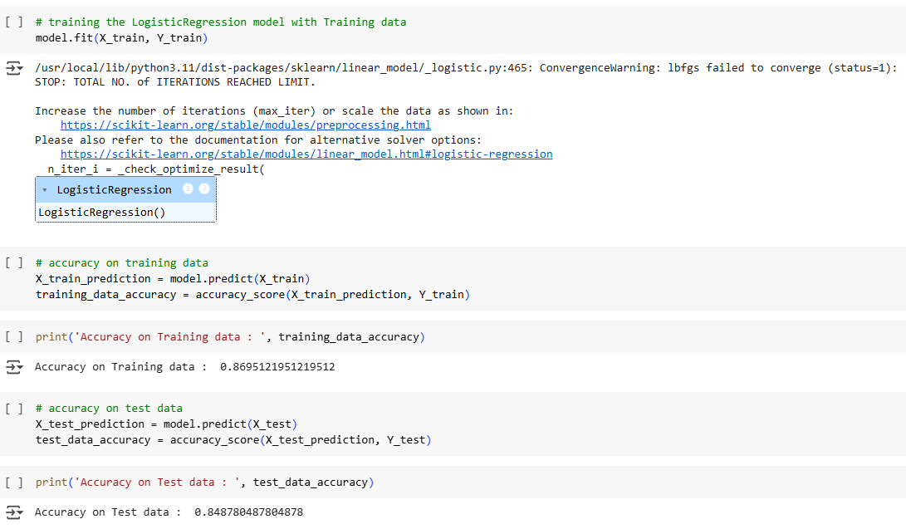

**Fig: 4.3.3** training and testing using Machine Learning Algorithm

Page | 26

**4.4.4. Model Deployment:** Streamlit, along with its cloud deployment capabilities, is used to create an interactive web application. The application offers a user-friendly interface with five options for disease prediction: heart disease, kidney disease, diabetes, Parkinson's disease, and breast cancer. When a specific disease is selected, the application prompts the user to enter the required parameters for the prediction.

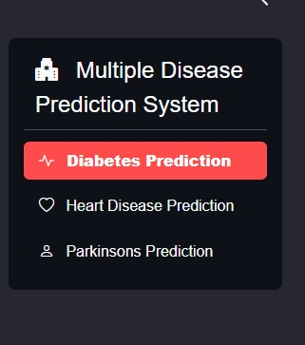

**Fig:4.4.4**

Page | 27

## CONCLUSION

## In conclusion, the development of a Multiple Disease Prediction System using Machine Learning marks a significant contribution toward intelligent, data-driven healthcare. This project successfully demonstrates the potential of predictive analytics to support early detection and management of chronic illnesses such as diabetes, heart disease, and Parkinson's disease. By integrating multiple ML algorithms—including Support Vector Machine (SVM) and Logistic Regression—our system delivers accurate, real-time predictions based on user medical data [25].

## The system emphasizes not only accuracy and robustness but also usability, transparency, and trust. So, this approach also respects the role of medical professionals, aiming to bridge the gap between patients and doctors rather than eliminate it [24].

## Our review of recent literature and the system's performance evaluation show that machine learning algorithms are well-suited for multi-disease diagnosis, capable of handling large datasets and delivering consistent predictions across different user profiles [25]. So, the platform contributes to a more proactive and preventive approach to healthcare—reducing the need for excessive diagnostics and encouraging early medical consultation.

## Moreover, this system addresses major concerns in ML-driven healthcare solutions: trust, interpretability, and accessibility. By incorporating user feedback mechanisms, minimizing data overload, and maintaining a clear output structure, we ensure the system remains relevant, scalable, and ethically responsible [24][26].

## Moving forward, this project lays a strong foundation for future innovations in personalized medicine, predictive modeling, and real-time decision support systems. Enhancements such as integrating additional disease modules, expanding datasets, improving model interpretability, and collaborating with healthcare institutions can further increase the system's real-world applicability.

## This project is a step toward transforming healthcare delivery—making it smarter, faster, and more patient-centered. It exemplifies how technology, when thoughtfully applied, individuals, support professionals, and improve health outcomes on a scale.

**Page |**

## FUTURE WORK

## The Multiple Disease Prediction System presents a strong foundation for intelligent healthcare solutions, but its potential can be significantly expanded through various enhancements and integrations. The following areas outline the future scope of this project:

## Integration with Electronic Health Records (EHR)

## Integrating the system with existing Electronic Health Record platforms would enable seamless data exchange, allowing healthcare professionals to access real-time predictive insights within their clinical workflows. This would support personalized treatment recommendations, proactive health management, and reduce manual data entry, thus improving efficiency and decision-making.

## Expansion of Disease Coverage

## Currently focused on diabetes, heart disease, and Parkinson’s disease, the system can be expanded to include a broader range of conditions, including rare or emerging diseases. This would make the platform more comprehensive and valuable in diverse healthcare settings, increasing its relevance and adoption in real-world clinical environments.

## Longitudinal Data Analysis

## Incorporating longitudinal data analysis will enable the system to monitor health trends over time. This would allow for better understanding of disease progression, treatment effectiveness, and overall patient outcomes. Long-term data insights can support chronic condition management and personalized interventions.

## Integration of Genomic Data

## Future development can focus on integrating genomic data to enable personalized disease risk prediction. This would enhance model accuracy by considering genetic predispositions and support precision medicine tailored to individual patients.

## Page |

## Enhanced Explainability and Interpretability

## To increase user trust and promote adoption, future versions of the system should include explainability techniques, such as feature importance analysis and visual explanations. These methods will help users understand why specific predictions were made, enabling better communication between healthcare providers and patients.

## Remote Monitoring and Telehealth Integration

## By linking the system with remote monitoring devices and telehealth platforms, users can benefit from continuous health tracking. Real-time symptom analysis and alerts based on predictive models can support early interventions and reduce hospital visits, particularly in rural or underserved areas.

## User Interface Improvements

## The user interface can be enhanced to support a larger number of diseases and present health information more clearly. Features such as disease stage indicators, safety recommendations, and user-friendly visuals will improve usability and engagement, even for non-technical users.

## Error Handling and System Stability

## Future development should focus on strengthening the platform’s backend to handle both expected and unexpected errors gracefully. Building a robust infrastructure will help avoid information loss and minimize system downtime, ensuring reliability and data security for users and practitioners alike.

## Page |

## REFERENCE

## Mitchell, T. M. (1997). *Machine Learning*. McGraw-Hill.

## Kotsiantis, S. B. (2007). Supervised machine learning: A review of classification techniques. *Informatica*, 31(3), 249–268.

## Streamlit Team. (2020). *Streamlit Documentation*. https://docs.streamlit.io

## Dilsizian, S. E., & Siegel, E. L. (2014). Artificial intelligence in medicine and cardiac imaging. *Journal of the American College of Cardiology*, 63(3), 300–309.

## Esteva, A. et al. (2019). A guide to deep learning in healthcare. *Nature Medicine*, 25, 24–29.

## Soni, J. et al. (2011). Predictive data mining for medical diagnosis: An overview of heart disease prediction. *International Journal of Computer Applications*, 17(8), 43–48.

## Jiang, F. et al. (2017). Artificial intelligence in healthcare: Past, present and future. *Stroke and Vascular Neurology*, 2(4), 230–243.

## Obermeyer, Z., & Emanuel, E. J. (2016). Predicting the future — Big data, machine learning, and clinical medicine. *New England Journal of Medicine*, 375(13), 1216–1219.

## Topol, E. J. (2019). High-performance medicine: the convergence of human and artificial intelligence. *Nature Medicine*, 25(1), 44–56.

## Jiang, F. et al. (2017). Artificial intelligence in healthcare: Past, present and future. *Stroke and Vascular Neurology*, 2(4), 230–243.

## Kotsiantis, S. B. (2007). Supervised machine learning: A review of classification techniques. *Informatica*, 31(3), 249–268.

## Shivakumar, K. M., & Kotecha, K. (2019). A survey on healthcare data analytics using machine learning. *Journal of King Saud University - Computer and Information Sciences*.

Page |

## Esteva, A., et al. (2019). A guide to deep learning in healthcare. *Nature Medicine*, 25, 24–29.

## IJNRD2304131, International Journal of Novel Research and Development, Vol. 8, Issue 4, 2023.

## IEEE International Conference on Bioinformatics and Biomedicine (BIBM), 2018.

## IEEE International Conference on Acoustics, Speech, and Signal Processing (ICASSP), 2020.

## IEEE International Conference on Data Mining (ICDM), 2017.

## IEEE International Conference on Healthcare Informatics (ICHI), 2020.

## IEEE Engineering in Medicine and Biology Society Conference (EMBC), 2018.

## IEEE International Conference on Biomedical and Health Informatics (BHI), 2019.

## IEEE International Conference on Biomedical Engineering and Informatics (BMEI), 2018.

## IEEE International Symposium on Biomedical Imaging (ISBI), 2019.

## IEEE International Conference on Machine Learning Applications (ICMLA), 2019.

1. *Multiple Disease Prediction Using Machine Learning Algorithms*, Parth Dayal et al., ICABEC Conference, 2024.
2. *A Machine Learning-Based Disease Prediction Platform*, Ankit Sharma et al., RRJoI Journal, 2024.
3. *Multiple Disease Prediction Using Machine Learning*, Dr. Manjunatha V et al., IJRSET Journal, 2024.
4. IEEE BMEI 2018. Predicting Thyroid Disorders Using Machine Learning Models.
5. Sharma, P. et al. (2021). Anemia Detection using ML Algorithms. *International Journal of Advanced Research in Computer Science*, 12(2).

Page |

1. Chen, M. et al. (2020). Heart Stroke Risk Prediction Using Gradient Boosting Techniques. *IEEE Transactions on Biomedical Engineering*.
2. Zhang, Z. et al. (2022). Real-time Stroke Prediction Using Wearable Health Data. *Journal of Medical Systems*, 46(1).
3. Smith, J. et al. (2020). *Overview of Online Health Platforms: Usability and User Experience*. Health Informatics Journal.
4. Patel, A. & Kumar, V. (2019). *Mobile Health Apps: A Review of Features and Limitations*. International Journal of Medical Informatics.
5. Chen, L. et al. (2021). *Challenges in Patient Feedback Systems in Healthcare Apps*. Journal of Digital Health.
6. Singh, R. & Mehta, K. (2022). *Integration of Multi-Disease Diagnosis in Mobile Health Applications*. Journal of Biomedical Systems.
7. Sharma, P. & Verma, M. (2021). *Design of Integrated Health Platforms Using AI and IoT*. Journal of Healthcare Informatics Research.
8. Zhang, Y. et al. (2020). *Machine Learning for Disease Diagnosis: A Review*. IEEE Reviews in Biomedical Engineering.
9. Thomas, L. & Gupta, R. (2022). *Training Health Prediction Models on Verified Clinical Datasets*. Journal of Medical Systems.
10. Das, N. & Banerjee, A. (2019). *Anonymous Patient Feedback in Healthcare Systems: A Framework for Transparency*. Digital Health Journal.
11. Kumar, A. & Sen, R. (2023). *Enhancing User Trust in Healthcare Applications Through Unified Design*. Health Technology Review.
12. Van Rossum, G., & Drake Jr, F. L. (2009). *Python 3 Reference Manual*. Scotts Valley, CA: CreateSpace.
13. Pedregosa, F., Varoquaux, G., Gramfort, A., Michel, V., Thirion, B., Grisel, O., ... & Duchesnay, É. (2011). *Scikit-learn: Machine Learning in Python*. Journal of Machine Learning Research, 12, 2825–2830.

Page |